**Answer to the Question Number 01:**

#include<stdio.h>

int maximum(int *arr, int n)

{

int i,max;

max=arr[0];

for(i=1;i<n;i++)

if(arr[i]>max)

max=arr[i];

return max;

}

int main()

{

int i,j,*arr,n,max,var;

printf("enter number of elements in the histogram: ");

scanf("%d",&n);

arr= (int*) malloc((sizeof(int)) * n) ;

for(i=0;i<n;i++)

scanf("%d",&arr[i]);

max=maximum(arr,n);

var=max;

for(j=0;j<var;j++)

{

for(i=0;i<n;i++)

{

if(arr[i]<max)

printf(" ");

else

printf("#");

}

max--;

printf("\n");

}

getch();

}

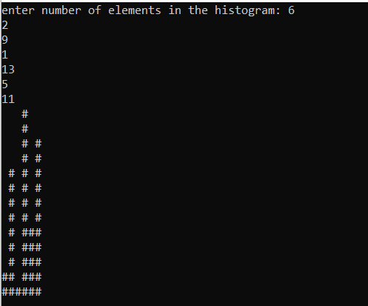

**Answer to the Question Number 02:**

#include<stdio.h>

#include <stdlib.h>

int main(){

int M[50],n=0,k

,i,g = 0;

srand(time(0));

for(i=0;i<50;i++){

M[i] = (rand() % 50)+1;

}

for(i=0;i<50;i++){

printf("%d ",M[i]);

}

while(1){

printf("\nEnter a number: ");

scanf("%d",&n);

if(n==-1){

break;

}

for(i=0;i<50;i++){

if(M[i]==n){

g = 1;

break;

}

}

if(g == 1){

printf(" present !\n");

g = 0;

}else{

printf("not present !\n");

}

}

}

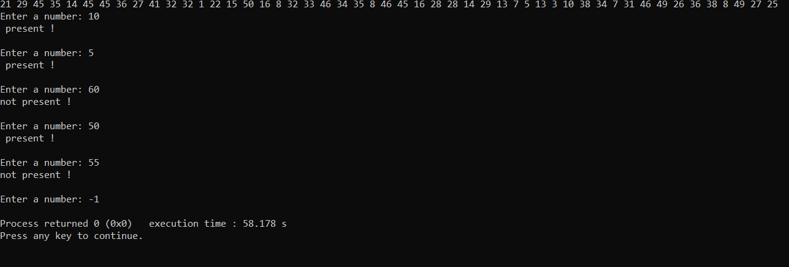

**Answer to the Question Number 03:**

#include<stdio.h>

int main()

{

int m[100],n,o = 0,i,k = 0,p,j;

scanf("%d",&n);

while(n!=-1){

m[k] = n;

k = k + 1;

scanf("%d",&n);

}

for(i=0;i<k;i++){

o = 1;

for(j=i+1;j<k;j++){

if(m[i]==m[j]){

o = o + 1;

p = m[i];

}

}

if(o>1){

break;

}

}

if(o>1){

printf("%d %d\n",p,o);

}else{

printf("None");

}

}

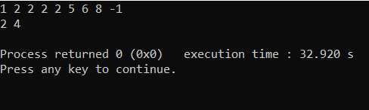

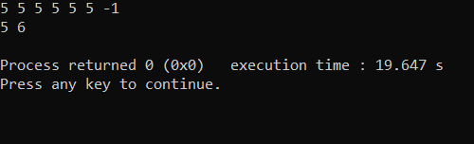

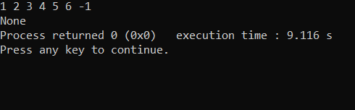

**Answer to the Question Number 04:**

#include<stdio.h>

int main()

{

int a[20];

int i,j, count =0;

printf("Give 20 numbers between 10 to 100: ");

for(i=0; i<20; i++)

{

scanf("%d",&a[i]);

if(a[i]<10 || a[i]>100)

{

printf("give number between 10 to 100 only. \n");

i++;

}

}

printf("Given numbers after duplicate elimination are: ");

for(i=0; i<20; i++)

{

for(j=0; j<i; j++)

{

if(a[i] == a[j])

break;

}

if(i==j)

{

printf("%d\n",a[i]);

count++;

}

}

if(count ==20)

{

printf("All elements are different.\n");

}

}

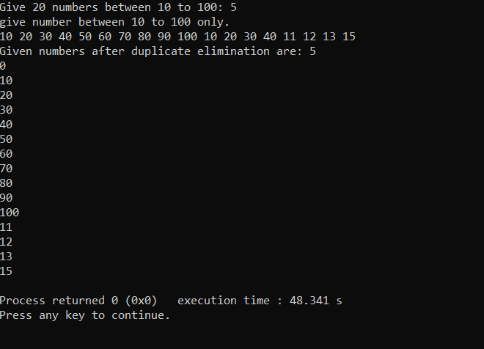

**Answer to the Question Number 05:**

#include<stdio.h>

int lS(int a[], int l, int n, int k)

{

if(n<l)

{

return -1;

}

if(a[l]==k)

{

return l;

}

if(a[n]==k)

{

return n;

}

return lS(a,l+1,n-1,k);

}

int main()

{

int a[100],n,key, sub = -1, i;

printf("Enter size of the array: ");

scanf("%d",&n);

printf("\nEnter array elements: ");

for(i=0;i<n;i++)

{

scanf("%d",&a[i]);

}

printf("\nEnter search key: ");

scanf("%d",&key);

sub = lS(a,0,n,key);

if(sub != -1)

{

printf("%d is found at subscript %d\n",key,sub);

}

else

{

printf("%d is not found!\n",key);

}

}

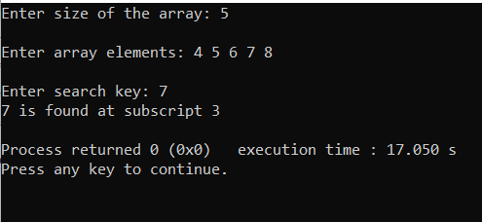

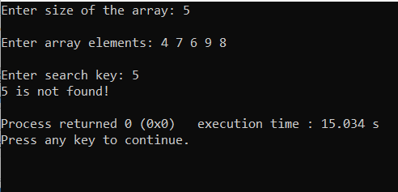

**Answer to the Question Number 06:**

#include <stdio.h>

#include <stdlib.h>

int main()

{

int arr1[50][50], brr1[50][50];

int i, j, r1, c1, r2, c2, flag =1;

printf("Input Rows and Columns of the 1st matrix :");

scanf("%d %d", &r1, &c1);

printf("Input Rows and Columns of the 2nd matrix :");

scanf("%d %d", &r2,&c2);

printf("Input elements in the first matrix :\n");

for(i=0;i<r1;i++)

{

for(j=0;j<c1;j++)

{

printf("element - [%d],[%d] : ",i,j);

scanf("%d",&arr1[i][j]);

}

}

printf("Input elements in the second matrix :\n");

for(i=0;i<r2;i++)

{

for(j=0;j<c2;j++)

{

printf("element - [%d],[%d] : ",i,j);

scanf("%d",&brr1[i][j]);

}

}

printf("The first matrix is :\n");

for(i=0;i<r1;i++)

{

for(j=0;j<c1 ;j++)

printf("% 4d",arr1[i][j]);

printf("\n");

}

printf("The second matrix is :\n");

for(i=0;i<r2;i++)

{

for(j=0;j<c2 ;j++)

printf("% 4d",brr1[i][j]);

printf("\n");

}

if(r1 == r2 && c1 == c2)

{

printf("The Matrices can be compared : \n");

for(i=0; i<r1; i++)

{

for(j=0; j<c2; j++)

{

if(arr1[i][j] != brr1[i][j])

{

flag = 0;

break;

}

}

}

}

else

{ printf("The Matrices Cannot be compared :\n");

exit(1);

}

if(flag == 1 )

printf("Two matrices are equal.\n\n");

else

printf("But,two matrices are not equal\n\n");

}

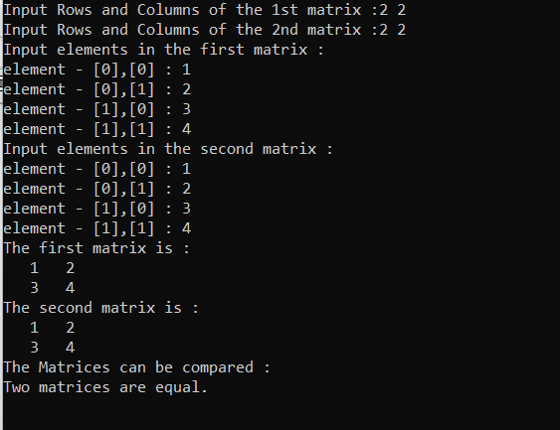

**Answer to the Question Number 07:**

#include <stdio.h>

int f(int *a, int n )

{

int i, Result = 0;

for(i = 0; i < n; i++)

{

Result = Result ^ a[i];

}

return Result;

}

int main()

{

int i;

int a1[] = {8, 3, 8, 5, 4, 3, 4, 3, 5};

int ctr = sizeof(a1)/sizeof(a1[0]);

printf("The given array is : ");

for(i = 0; i < ctr; i++)

{

printf("%d ", a1[i]);

}

printf("\n");

printf("Number of odd number occur(s) : %d times.\n", f(a1, ctr));

return 0;

}

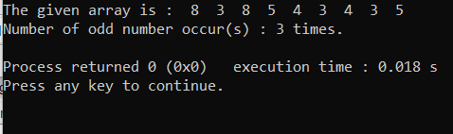

**Answer to the Question Number 08:**

#include <stdio.h>

int m2a(int *b, int ba, int *s, int sa)

{

if(b == 0 || s == 0)

return;

int bi = ba-1,

si = sa-1,

m = ba + sa -1;

while(bi >= 0 && si >= 0) {

if(b[bi] >= s[si]){

b[m] = b[bi];

m--;

bi--;

} else {

b[m] = s[si];

m--;

si--;

}

}

if(bi < 0)

{

while(si >= 0)

{

b[m] = s[si];

m--;

si--;

}

} else if (si < 0)

{

while(bi >= 0)

{

b[m] = b[bi];

m--;

bi--;

}

}

}

int main()

{

int bigArr[13] = {10, 12, 14, 16, 18, 20, 22};

int smlArr[6] = {11, 13, 15, 17, 19, 21};

int i;

printf("The given Large Array is : ");

for(i = 0; i < 7; i++)

{

printf("%d ", bigArr[i]);

}

printf("\n");

printf("The given Small Array is : ");

for(i = 0; i < 6; i++)

{

printf("%d ", smlArr[i]);

}

printf("\n");

m2a(bigArr, 7, smlArr, 6);

printf("After merged the new Array is :\n");

for(i = 0; i<13; i++)

{

printf("%d ", bigArr[i]);

}

return 0;

}

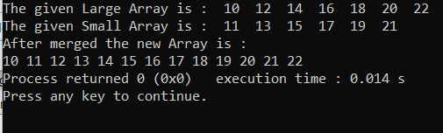

**Answer to the Question Number 09:**

#include <stdio.h>

int main()

{

int arr1[100],i,n,p,v;

scanf("%d", &n);

printf("Input %d elements in the array in ascending order:\n",n);

for(i=0;i<n;i++)

{

printf("element - %d : ",i);

scanf("%d",&arr1[i]);

}

printf("Input the value to be inserted : ");

scanf("%d",&v);

printf("The exist array list is :\n");

for(i=0;i<n;i++)

printf("% 5d",arr1[i]);

for(i=0;i<n;i++)

{

if(v<arr1[i])

{

p = i;

break;

}

else

{

p=i+1;

}

}

for(i=n+1;i>=p;i--)

arr1[i]= arr1[i-1];

arr1[p]=v;

printf("\n\nAfter Insert the list is :\n");

for(i=0;i<=n;i++)

printf("% 5d",arr1[i]);

printf("\n");

}

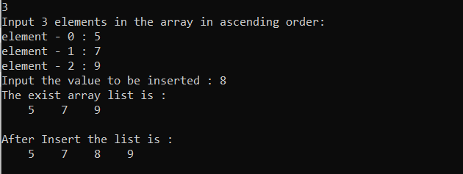

**Answer to the Question Number 10:**

#include<stdio.h>

int main(){

int i,j,k,s,p;

float sales,a[6][6], total = 0.0;

for(i=0;i<=5;i++){

for(j=0;j<=5;j++){

a[i][j] = 0.00;

}

}

printf("Enter the salesperson (1 - 4), product number (1 - 5) and total sales.\n");

printf("Enter -1 for the salesperson to end input.\n");

while(1){

scanf("%d",&s);

if(s==-1){

break;

}

scanf("%d",&p);

scanf("%f",&sales);

a[s][p] = sales;

}

printf("The total sales for each sales person are displayed at the end of each row,\n");

printf("and the total sales for each product are displayed at the bottom of eachcolumn.\n\n");

for(i=1;i<=5;i++){

printf(" %d",i);

}

printf(" Total\n");

for(i=1;i<=4;i++){

total = 0.00;

for(j=1;j<=5;j++){

total = total + a[i][j];

}

a[i][6] = total;

}

for(i=1;i<=4;i++){

total = 0.00;

for(j=1;j<=5;j++){

total = total + a[i][j];

}

a[i][6] = total;

}

for(j=1;j<=6;j++){

total = 0.00;

for(i=1;i<=4;i++){

total = total + a[i][j];

}

a[5][j] = total;

}

for(i=1;i<=4;i++){

printf("%d",i);

for(j=1;j<=6;j++){

printf(" %.2f",a[i][j]);

}

printf("\n");

}

printf("\n\nTotal ");

for(j=1;j<=5;j++){

printf("%.2f ",a[5][j]);

}

}

